***La Jetée* (The Jetty) (1962)**

Thomas Patrick Pringle (McGill University)

*La Jetée* is an influential ciné-roman (film-novel) made by Left Bank director Chris Marker. In a post-apocalyptic dystopia, scientists send an unnamed protagonist travelling through time in search of aid for the present, a process he survives because he retains a clear childhood memory of a woman standing on a jetty. Upon arriving in the past, the character meets the woman from his memory and falls in love, only to be recalled by his tormentors for further tasks. The film is aesthetically important for Marker’s use of still-photography, with the sole excepting one shot of subtle movement, and voice-over for narration. The style is narratively significant, as the film poses time travel as an internal journey through recollected images, leaving open philosophical questions about cinema’s complex relation to time and memory. Each subsequent still image holds ties to both past and future. The protagonist eventually seeks refuge with his love in the past, only to be assassinated by a killer from the future. The death reenacts a memory carried by the protagonist, who, as a young boy, had already watched his own destined execution on the jetty. *La Jetée* has had enduring influence and has been the object of several homages, such as Terry Gilliam’s adaptation, *Twelve Monkeys* (1995).

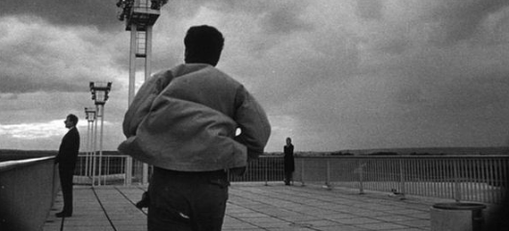  
Image source: <http://www.soundonsight.org/sound-on-sights-best-films-ever-made/>

Clip from La Jetée:  
<http://www.youtube.com/watch?v=1WXMp5BHZ_o>

Short documentary on Marker:  
<http://www.youtube.com/watch?v=1HrujmaJ5zU>

References and Further Reading:

Alter, Nora M. (2006) *Chris Marker*. Urbana: University of Illinois UP.

Cooper, Sarah. (2008) *Chris Marker*. Manchester: Manchester UP.

Friedlander, Eli, and Dror Dolfin. (2001) “*La Jetée*: Regarding the Gaze.” *Boundary 2.* 28.1:75-90.

Harbord, Janet. (2009) *La Jetée*. Cambridge: MIT UP.

Lupton, Catherin. (2005) *Chris Marker: Memories of the Future*. London: Reaktion Books.